**DATA INGESTION TASKS**

**Task- 1**

* Create an RDS instance in your AWS account and upload the data to the RDS instance

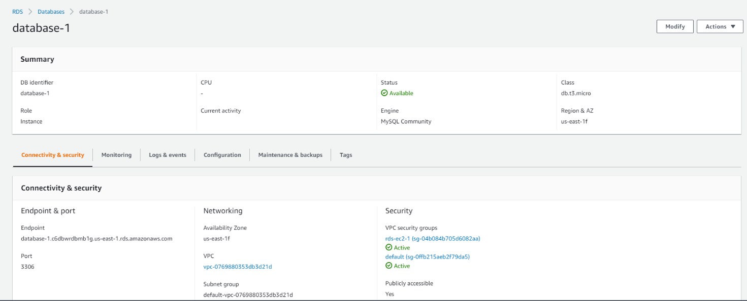

* Create an EMR Cluster in your AWS account and setting up an EC2 instance connection between EMR cluster and the RDS Instance.

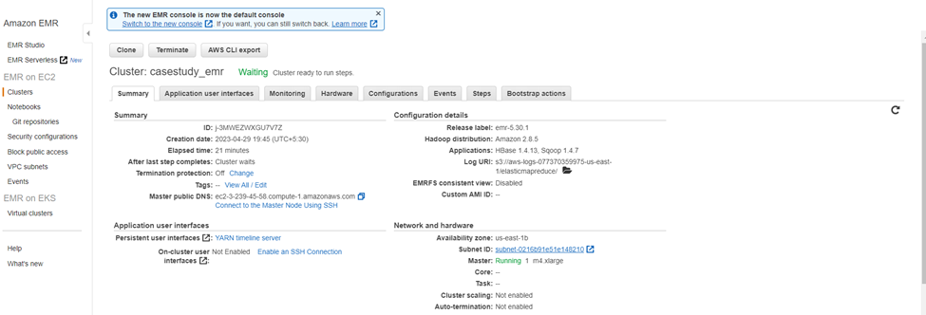

* Creating SQL Table to store data
* CREATE TABLE IF NOT EXISTS yellow_trip

(

VendorID INT,

tpep_pickup_datetime TIMESTAMP,

tpep_dropoff_datetime TIMESTAMP,

passenger_count INT,

trip_distance FLOAT,

RatecodeID INT,

store_and_fwd_flag VARCHAR(10),

PULocationID INT,

DOLocationID INT,

payment_type INT,

fare_amount FLOAT,

extra FLOAT,

mta_tax FLOAT,

tip_amount FLOAT,

tolls_amount FLOAT,

improvement_surcharge FLOAT,

total_amount FLOAT,

congestion_surcharge FLOAT,

Airport_fee FLOAT,

tripID INT NOT NULL AUTO_INCREMENT,

PRIMARY KEY (tripID)

);

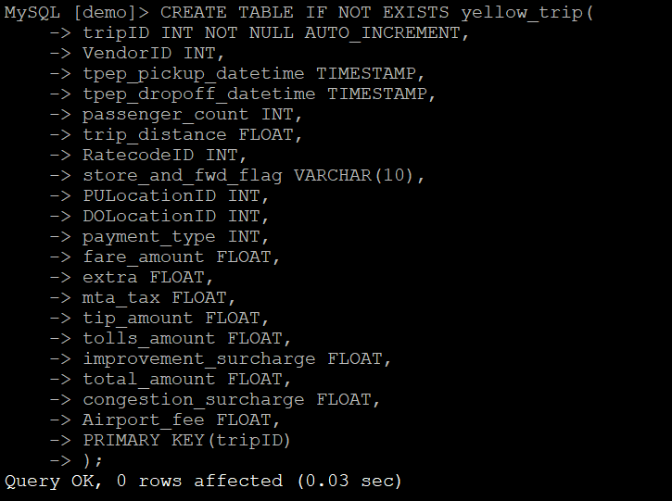

* Load data from csv files to SQL Table:

LOAD DATA LOCAL INFILE '/home/hadoop/nyc/yellow_tripdata_2017-01.csv'

INTO TABLE yellow_trip

FIELDS TERMINATED BY ','

LINES TERMINATED BY '\n'

IGNORE 1 LINES;

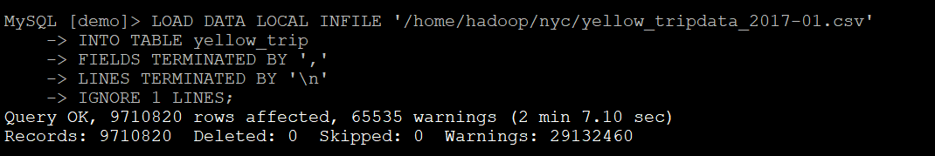

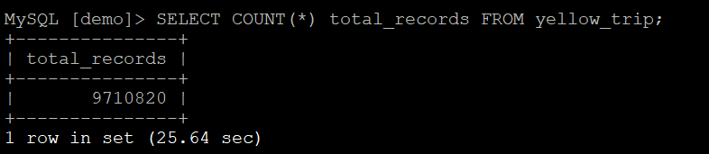

* Load yellow_tripdata_2017-02.csv

LOAD DATA LOCAL INFILE '/home/hadoop/nyc/yellow_tripdata_2017-02.csv'

INTO TABLE yellow_trip

FIELDS TERMINATED BY ','

LINES TERMINATED BY '\n'

IGNORE 1 LINES;

* Checking the Records in table after loading the data
* There is total 18880595 records are present in table.

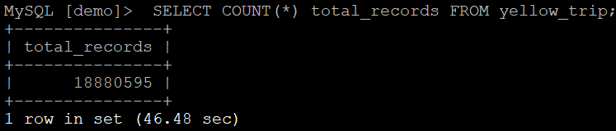

* Select 5 rows from table by using this SQL query:

SELECT * FROM yellow_trip LIMIT 5;

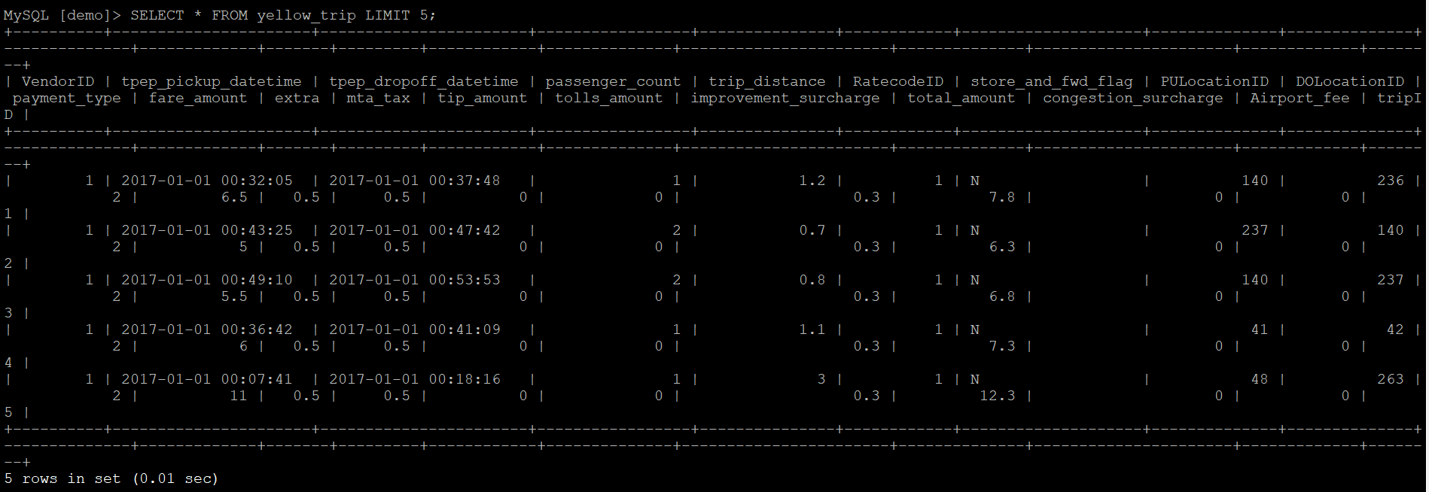

**TASK- 2**

Using Sqoop command to ingest the data from RDS into the HBase Table.

sqoop import --connect jdbc: mysql://database-1.c6dbwrdbmb1g.us-east-1.rds.amazonaws.com/demo \

--username admin \

--password mysql123 \

--table yellow_trip \

--hbase-table yellow_trip_hb \

--hbase-row-key tripID \

--column-family yellow_trip_columns --hbase-create-table -m 4;

